Bahria University,
Karachi Campus
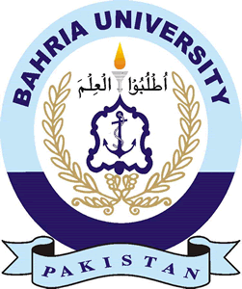
COURSE: CSL-210 OBJECT ORIENTED PROGRAMMING
TERM: SPRING 2023, CLASS: BSE- 2 (B)

Submitted By:

81962
ABDULLAH
(Name) (Reg. No.) .

Submitted To:

Engr. SANIYA SHAIKH

Signed Remarks: Score: .

INDEX
SNO | DATE | LAB NO | LAB OBJECTIVE | SIGN
SNO | DATE | LAB NO | LAB OBJECTIVE | SIGN
Bahria University,
Karachi Campus


LAB EXPERIMENT NO.
_______
05
LIST OF TASKS
TASK NO | OBJECTIVE
01 | Draw a Flowchart for Ordering a Book.
02 | Draw a Flowchart for Taking Admission in University.
03 | Draw a Flowchart for Fee payment procedure in a University.
04 | Draw a Flowchart for Reporting a crime in Police Station.
05 | Draw a Flowchart for Hiring a Cab.

Submitted On:
____________
/10/22
(Date: DD/MM/YY)
Task No. 1:
Solution:
Output:

